<Body>

Template

Sldjfsqdljfsd f

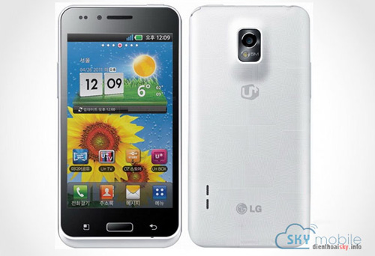

Figure : aaaaa

²

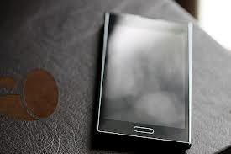

<extend>

<image1 map stock>